**Mr. Visca’s: Calculus (Chpt 5.2)**

**Chpt 5 – Day 2: Definite Integrals**

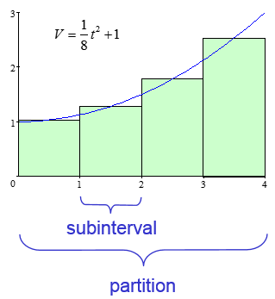

When we find the area under a curve by adding rectangles (LRAM,RRAM,MRAM), the answer is called a **__________________**.

The width of a rectangle is called a **___________________**.

The entire interval is called the **___________________**.

*Subintervals do not all have to be the same size.*

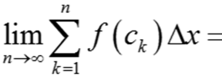

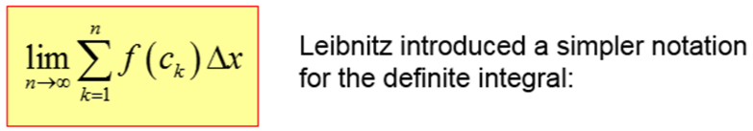

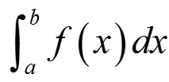

Integrals are the **REVERSE** process of derivatives

**Derivatives:** **Integrals:**

1. ______________ by exponent 1. ______________ to exponent

2. _______________ from exponent 2. _______________ by exponent

ex. find dy/dx of 5x2 ex. Integrate 10x

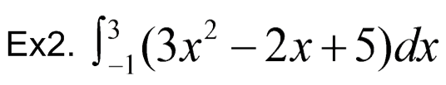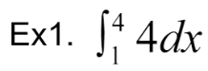**So...how do we use/perform this integration?**

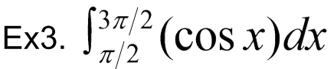

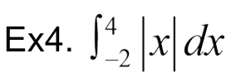Using Geometry to make it easy (sometimes ☺ )

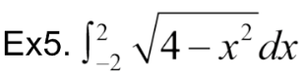

***Calculator, how I love thee!!!***

1. **__________________**
2. **__________________**
3. **__________________**

**HOMEWORK:**

Page 282-283: 7-12 all, 14-32 even